

# 1. Introduction

Reporting Robot

The TQA Reporting Robot is a UiPath Process which can be used to retrieve queue items and the information stored within them from a specific queue in Orchestrator using a variety of filters (**Important: Only supported for Cloud Orchestrator)**

When a queue item is created in Orchestrator, information can be added in the “Specific Content” of the item itself, as well as the “Reference” field, and this information can be useful when extracting reports.

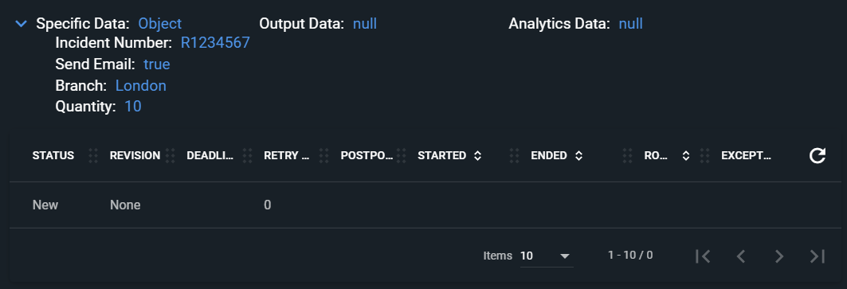

Furthermore, when a transaction status on a queue item is set, additional information can be added in various other fields depending on the transaction outcome (Failed/Successful):

* Transaction Successful: information can be added under “Output” on the “Set Transaction Status”

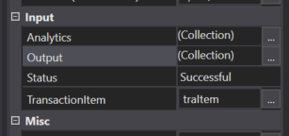

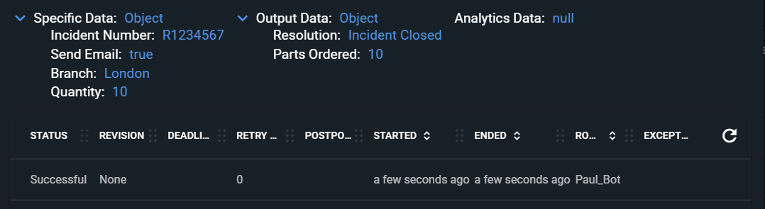

* Transaction Failed: information can be added under “Details” and “Reason”, where a message can be presented.

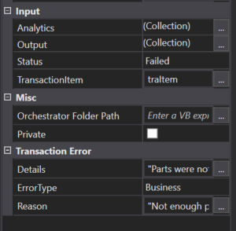

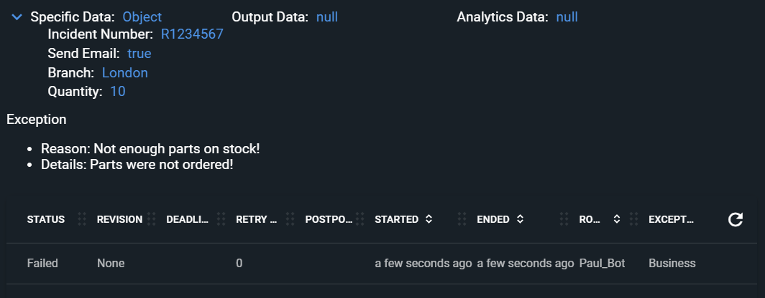

The TQA Reporting Robot has a filter feature which can be used to produce reports based on specific days:

* Everything
* Daily
* Yesterday
* Specific Date

# 2. Filter Choice

* Everything:
  + Will extract all queue items for that queue, up to a **maximum** of 1000 queue items.
* Daily
  + Will extract all queue items that were created in the current day until the robot runs.
  + Ex. If Reporting Robot is scheduled at 4PM Daily and the Filter choice is set to “Daily” it will extract all queue items that were created today up until 4 PM.
* Yesterday
  + Will extract all queue items that were created in the previous day
* Specific Date
  + This parameter accepts a specific date in the format “DD-MM-YYYY”, and it will extract all queue items created in that day

# 3. How to use

Once the .nupkg was imported into Orchestrator, simply create a new Process and fill the below parameters:

**Package Name**: TQA_Reporting

**Display Name:** Reporting_QueueName_FilterChoice - > the name you want to be displayed in Orchestrator when this process runs.

**OrchestratorQueueName:** the name of the queue from which the robot will extract information from

**FilterChoice:** - choice of when you want the data to be extracted (see Section Filter choices for further details)

**ReportFilePath:** this should represent the path where the reporting document will be produced

**EmailRecipients (optional):** this is an optional field, meaning it can be left blank. If left blank robot will not send report via email. If filled it needs to represent the email address of who will receive the report via an email.

**DeleteLocalReporting:** Only two values can be inserted: True or False. If True, it will delete the local copy after it’s produced. If false, the report will be created and saved under the file path mentioned above and the document will not be deleted.

